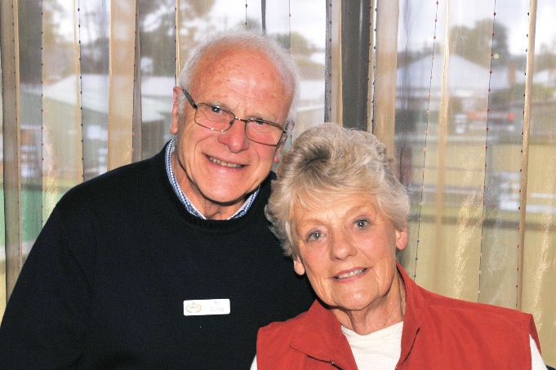  
*Barb and Ric Dunlop*

**My memories**

**written by BARB DUNLOP**

When the Royal South Street Society was approaching 100 Years of Competitions, I was asked to direct the planned CENTARY CONCERT August 17th, 1991

My background in theatre, performance and other productions apparently was mentioned to the then Committee and I was asked to produce this event. It was such an honour and a wonderful experience.

Sometime later I was invited to join the Committee. The days leading up to my first meeting will never be forgotten. The Honour Board, listing RSSS Presidents in Lucky’s Foyer says it all. ALL MEN- and such eminent gentlemen over the years. It is my understanding that the late Keith Allen and Ted Lewis proposed my nomination, and to them I will be eternally grateful.

I cannot speak more warmly of the welcome I received from the Committee. Their experience was generously shared, their patience with the “new chum” was wonderful and I honestly felt that there was a new role for me to embrace. We wore special RSSS blazers, and to match the men, I invested in grey skirts and slacks.

Soon after joining I was appointed to the Theatre Board and served for many years on the Programming Sub Committee.

In those days the Committee was the driving force and decision makers for the Society. Nearly all Committee members were responsible for a Discipline and/ or a leader in other aspects of the Comps.

When changes were mooted to improve the running or special conditions of a Discipline, it was presented to the entire Committee for discussion. The cost, management, feasibility, and viability were well considered by all and their long experience proved to be an excellent fine sieve for success. Believe me, changes were well researched and strongly debated. We were wonderfully supported by exceptional office staff.

Over time I too was entrusted with several Disciplines. When Pianoforte came into my hands, I researched the audience numbers at Her Maj, looked at the age groups and felt that there was a need to move this away from the Theatre. Why? A huge bare stage, a grand piano which must have been daunting in itself, the long walk to center stage and the few people in the audience. I well remember a very young student who, with tears in his wide eyes, tugged my jacket and stammered that “I won’t be able to find Middle C!”

It was not uncommon for the very young ones to hurriedly sit at the piano and play their piece either an octave higher or lower than intended. That year I accompanied the students to the piano and made sure that they were seated in front of Middle C. and. on occasions pointed out the magic note! The upshot was that the Committee agreed to move this Discipline to the Diocesan Centre. Speech and Drama and Debating soon followed. It was a great honour to chair the start of the Chopin Section too.

RSSS suppers were legendary! At the conclusion of every evening, Committee and wives entertained the visiting adjudicators, writers, and special guests in the Kittson Room. I realized early on that the table was presented in a particular manner and many ladies were fantastic cooks. Ric did not need to enter the cooking extravaganza but was always on hand to assist. It was the practice not to begin the washing up until our guests had left. I confess that having been in the Chair for hours I broke that rule and began when everyone had finished and were still chatting.

Over the years it was fascinating to engage Adjudicators, learn from them and together sort out the day to day procedures with them and their writers. No two Adjudicators operated in the same manner.

Each were different in need, focus and presentation and were honoured to be asked to Ballarat.

RSSS regularly presented two Prize Winner Concerts at the conclusion of the Comps - Junior and Senior. Eventually I was asked to facilitate a combined event which we named SHOWCASE.

We were able to present our artists in a manner befitting their talent. Lighting, staging and special effects all proved to be appreciated and worthy of each item. Yes, it was a lot of work for one performance, but we wanted to honour our artists.

I admit that I have a passion for greenery, and for Chopin, and Aria the stage was well dressed for the occasion. I was rebuked one evening for presenting a “horticultural show” for the Aria. None the less the wonderful reaction from the audience and singers when the curtain rose was worth the effort!

Being the first female and only female President has been an honour and I am sure that others will follow.

One of my special activities was to be a guest speaker at many organizations in Ballarat, Melbourne and elsewhere. Sharing the fun, magic and wonderful stories of RSSS down the years has been a delight.

Did you know that Dr Tony Cole not only ran the Dancing section with incredible attention to detail and love but frequently invented, produced and labored unstintingly to provide inventions that made our Comps so much better? It was not unusual to have a covered item on the table prior to a meeting. What was it? A gadget for improving some technical function, a light, an extra TV screen in the Chairman’s desk, a list of names with phonetics to assist with pronunciation or an engineering masterpiece for backstage. An amazing man.

My sincere focus at the beginning of a session was always to meet with the FOH staff. At the Theatre there is an invisible barrier between FOH, and Back stage and it must be eliminated.

The session Chairperson, meeting out front prior to the start of a session makes that bond and establishes an understanding.

Our systems have changed, improvements have been achieved but the Committee, as I knew it, was a truly wonderful group that encompassed the Comps at every level. After nearly 30 years I was thrilled to receive a LIFE MEMBERSHIP and both Ric and I have stepped away from involvement.

***Remember—ONE DOES NOT RETIRE- ONE CHANGES DIRECTION***

Barb D ~ June 2020