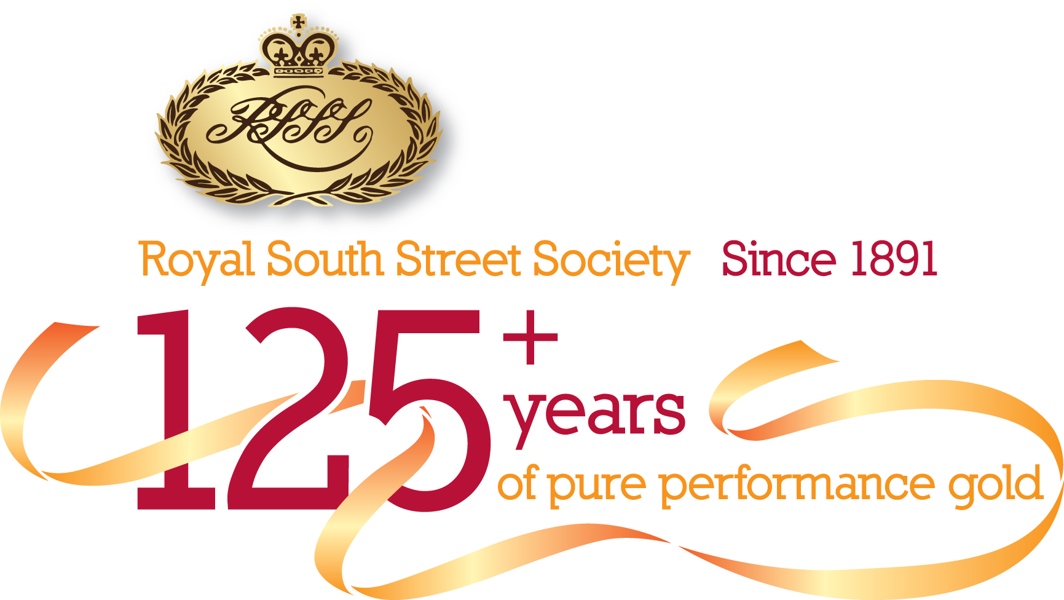 | Application for Dance Teacher Pass 2018  1870 Founder’s Theatre

All Teachers must have a Pass to gain FREE entry to backstage & Stalls area of the Theatre for the Engertiks Dance Sections. This Pass must be visible at all times while at the Theatre, so please make sure they are either pinned on in a lanyard, if not visible you will not be allowed entry – this also includes the security On booked session of Dance however this will not give you a seat in the auditorium.

Energetiks Dance is from September 22nd to October 6th, 2018.

Passes will be available by written application only. Passes cannot be issued “ON THE SPOT” and will only be issued ONCE. They may be picked up at the Royal South Street Society Box Office. If you do not have your Pass, you will be required to purchase a ticket at the Box Office before entering. If you have senior students who help with junior students, please encourage them to purchase their Student Pass prior to the dance discipline starting.

The Pass is intended for the main/deeply involved Teachers of the school; not every Assistant in the school. Each School will be issued FOUR named passes for use by the main principal or teachers of the school.

If you require more these can be applied for purchased at a cost of $35 each.

We ask that you please fill in all contact details below. We strongly request you provide an email address, as much of our 2018 competition updates and information will be via email.

Any queries regarding Passes should be directed to the Royal South Street Society Competitions Officer ~
Julie on 03 5332 1054. Email applications to julie@royalsouthstreet.com.au no later than Friday, 3rd August, 2018

Principal Teacher
School Name
Address
Telephone (BH) |  | (Mob)
Email Address

Name of Principal Teacher & Accredited Teachers (Passes will be named with the information provided)

1.Name: WWCC Number:
2.Name: WWCC Number:
3.Name: WWCC Number:

4.Name: WWCC Number:……………………………………… ………

Principal Teacher’s Children are required to purchase a Student Competitor Pass for $70

………………………………………………………………………………………………………………….

…………………………………………………………………………………………………………………

Please complete the Application for Assistant Teachers Pass (cost: $35 per additional pass) if required.

Submit this application to julie@royalsouthstreet.com.au no later than Friday, 3rd August, 2018

